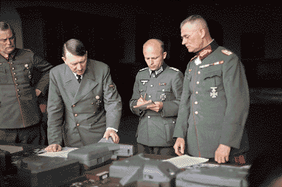
BY ORDER OF THE FUHRER

